CONGA COMPOSER

As an admin, you build a Composer solution and place that button on a page layout. Your end-users can then click the button to run the solution. You can allow end-users to make selections, such as which template to use for the final merged files, or you can pre-select templates and other options and run the solution entirely in the background. You can also automate solutions using Salesforce workflows or on a schedule.
Requirements
To install and successfully use Conga Composer®, you must have one of the following from each category:
Salesforce® Edition:
- Performance / Unlimited
- Enterprise
- Professional (limitations may exist)
- Developer
Salesforce® Products:
- Sales Cloud
- Service Cloud
- Force.com / App Cloud
- Health Cloud
- Financial Services Cloud
- Quote-to-Cash
Internet Browsers (latest stable version of):
- Firefox
- Chrome
- Internet Explorer
- Safari
- Microsoft Edge

Installation
Conga Composer® is available to install from the Salesforce® AppExchange.
To install Conga Composer:
- Install Conga Composer into your Salesforce instance by using below link
Conga Composer
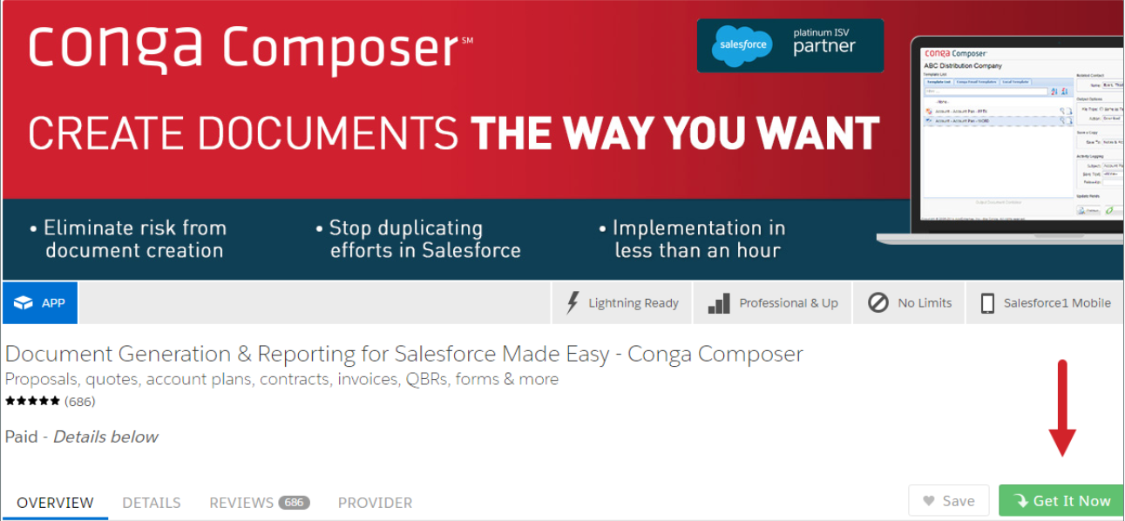
- Click Get It Now and follow the on-screen prompts to install Conga Composer.

- Log in to the AppExchange.
- Specify where you want to install Conga Composer.
- Click Install in production to install in your production instance.
- Click Install in sandbox to install in a sandbox.
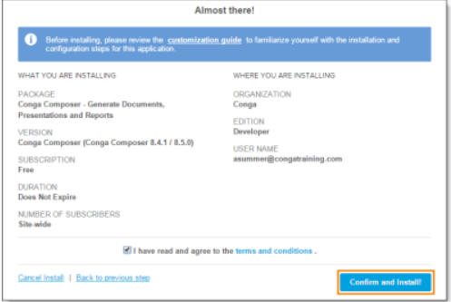
- Read and accept the terms and conditions.
- Select the I have read and agree to the terms and conditions box.
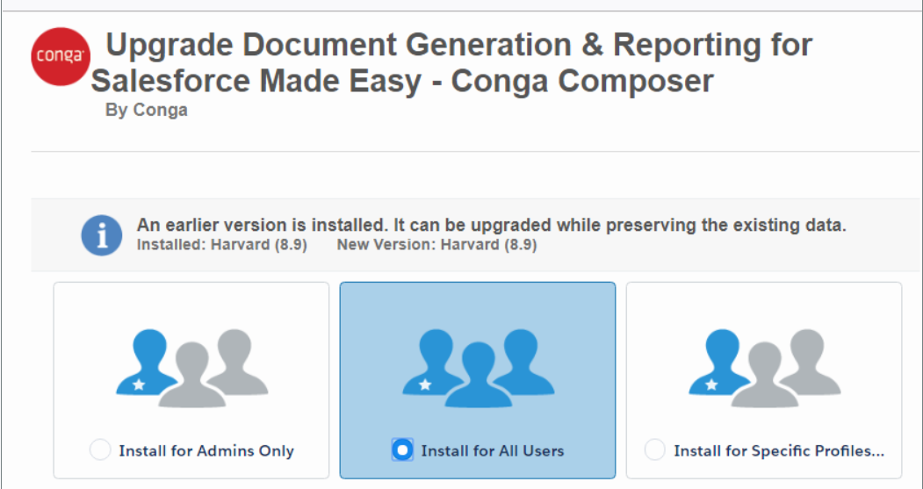
- Click Confirm and Install!

Conga Composer Setup
Under the Basic tab, you can change the default settings for local template usage, template manager repositories and solution behaviours. You must ensure that the following items are selected in the listed sections:
- Under the Conga Template Manager: Ensure Enable the new, built-in Conga Template Manager is checked (this should be enabled by default)
- Offline Access: Click Update Salesforce Token - If the Conga Scheduler Window opens, click Allow.
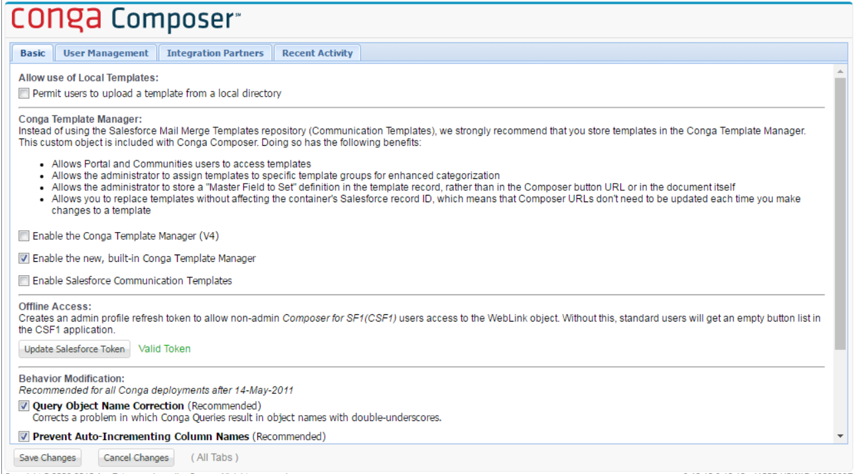
- Behaviour Modifications: Ensure all items are selected. (This should be enabled by default.)
Configure the Conga Composer Connected App
Administrators can pre-approve users to connect via OAuth when running solutions. This method masks the session ID and URL when using Visualforce buttons, and prevents pop-up authorization requests on mobile devices when running Composer solutions on Salesforce1.
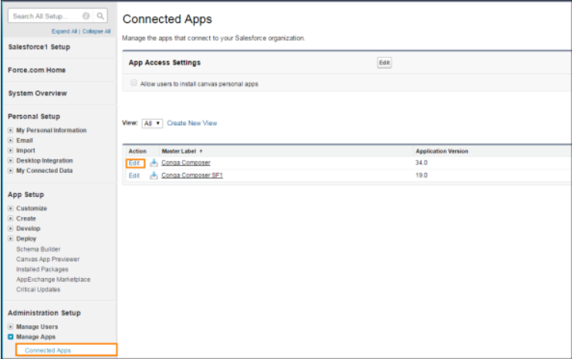
- Navigate to Setup > Manage Apps > Connected Apps > Conga Composer.

- Click Edit.
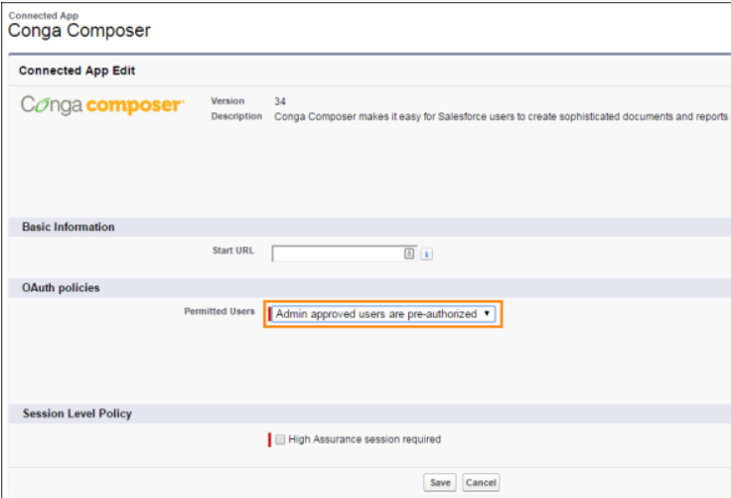
- Change the Permitted Users picklist to Admin approved users are pre-authorized.

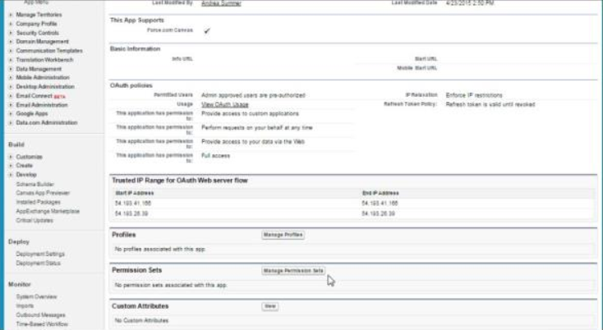
- Designate which users connect to Conga Composer via OAuth by adding Profiles (click Manage Profiles) or Permission Sets (click Manage Permission Sets).

